Etherac Technical Design Document

Version 1.0
Eric Nuernberger
Date

Table of Contents
Component Specification 3
Database Models 3
User 3
Song 4
Playlist 5
Views 6
Home 6
Library 7
Playlist 8
Now_Playing 9
Controllers 10
Services 11
References 12

Component Specification

Database Models

User
{

}

Song
{
SongId : ,
SongName : ,
Artist : ,
Album : ,
Lenght : ,
Genre : ,
Tags : [],
FileDir : ,
CoverArtDir : ,
Owner : ,
Library :
}

Playlist
{
SongId : ,
Position :
}

Views

Home

Library
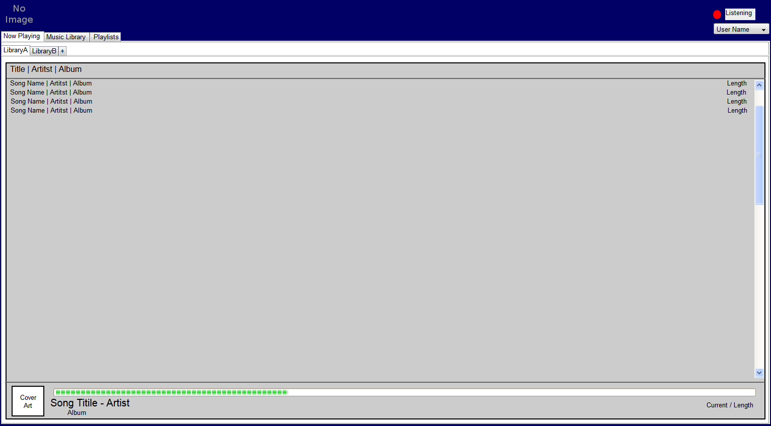

Playlist
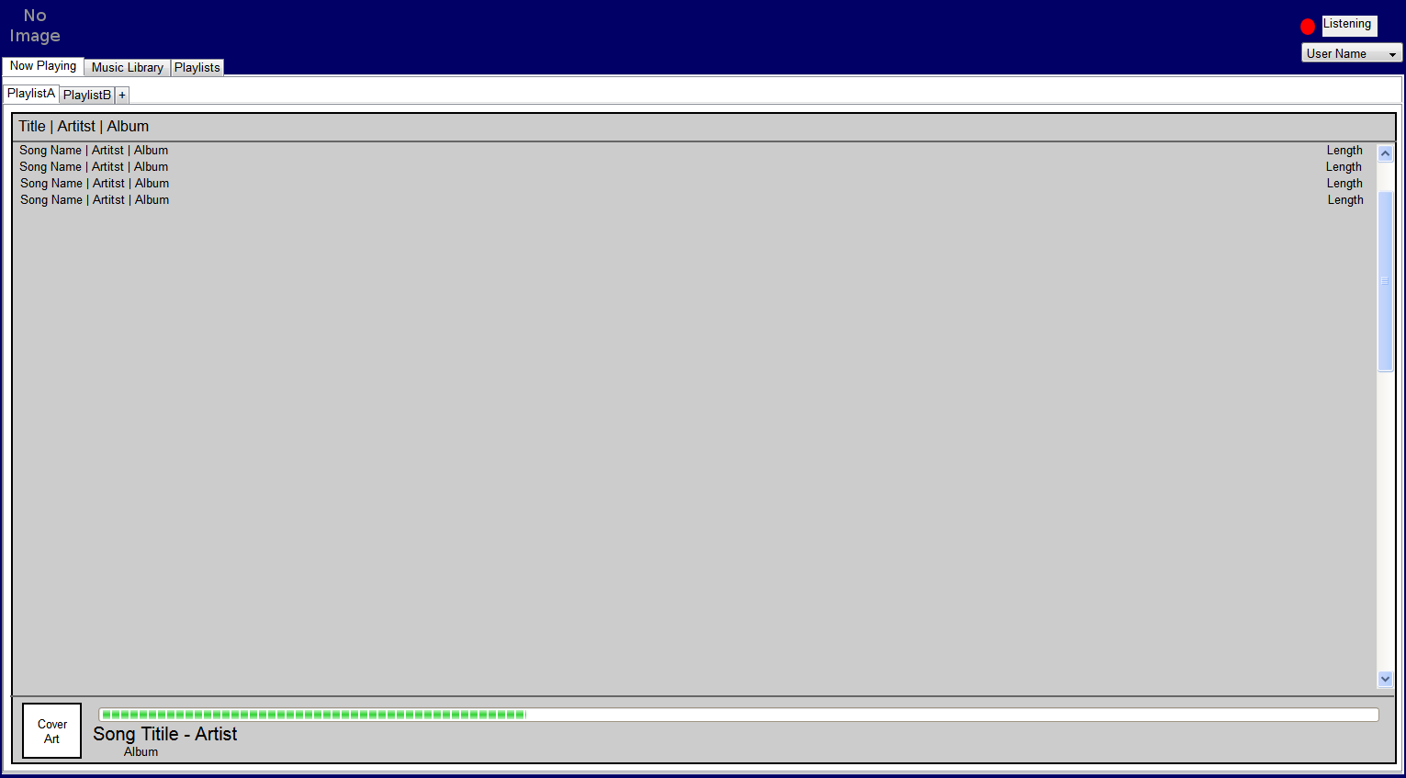

Now_Playing
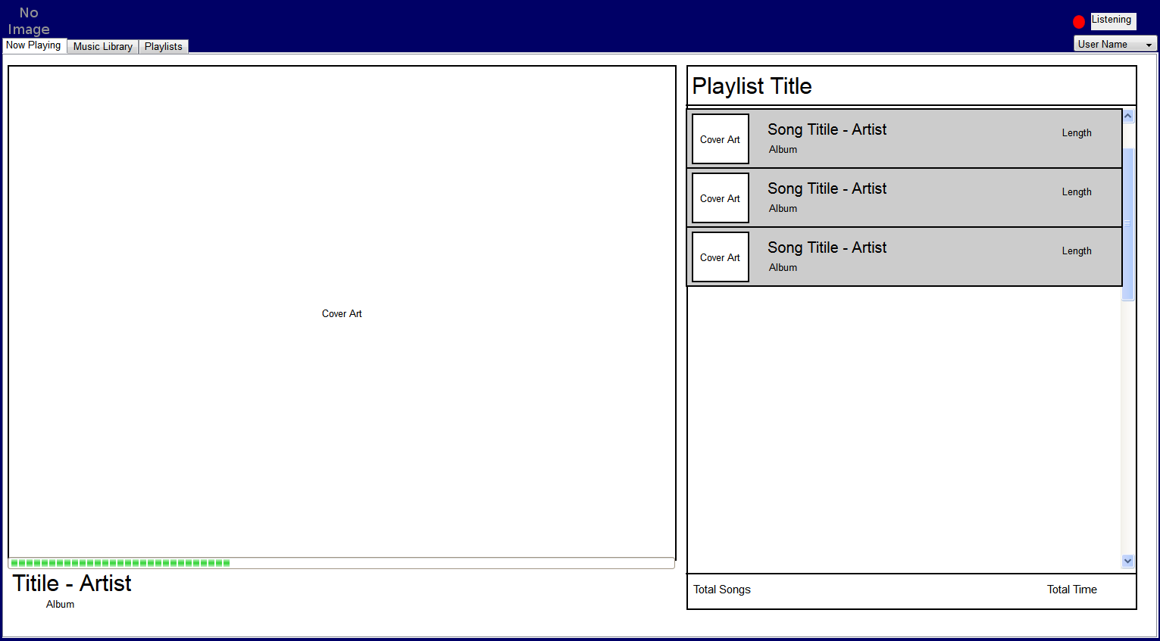

Controllers

Services

References

responsive-voice.js
https://gist.github.com/anchetaWern/ed6e841555602656e6ae

annyang
https://github.com/TalAter/annyang

sc-speech
https://github.com/safetychanger/sc-speech

butler
https://github.com/720kb/butler

artyom.js
https://github.com/sdkcarlos/artyom.js

